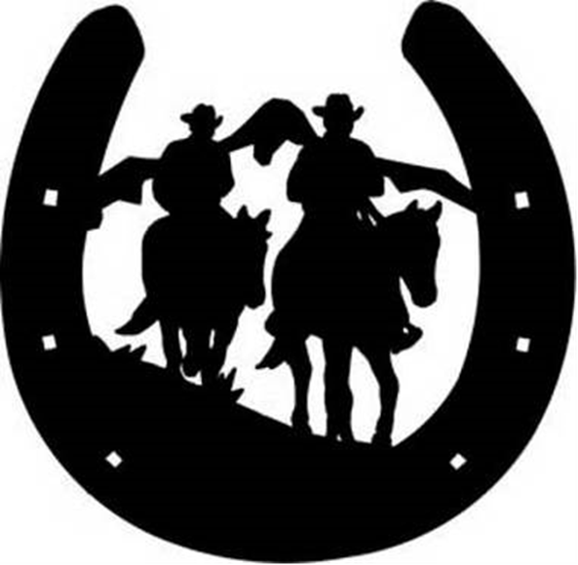
No Hour Of Life Is Wasted That Is Spent In The Saddle
Morpeth Horse Riders Club Inc.
MEMBERSHIP APPLICATION
OFFICE USE ONLY
Receipt No;
Initial;
NAME:
ADDRESS:
D.O.B: / / EMAIL:
PHONE: MOBILE:
EMERGENCY CONTACT (Name & Number):
Do you have Ambulance Cover? Yes or No
The MHRC is NOT liable for the cost of Ambulance Transport.
Membership includes Public Liability Insurance (NOT Personal Accident) whilst participating in MHRC Rides. Personal Accident Insurance is the responsibility of the individual rider NOT MHRC.
Payment Details:
BSB: 646 000
A/C:100082283
Your ID:

Please read the Code of Conduct over before you sign and return the form to the address below.
Signature:
Date:
Mail address: PO Box 1000 Clarence Town 2321
E-mail: alwynhelena77@gmail.com

CODE OF CONDUCT
I acknowledge that we are a walking club on our rides.
I acknowledge that horse riding is a dangerous sport and take full responsibility for my actions.
I understand that an approved riding safety helmet should be worn.
I understand that appropriate riding footwear must be worn.
All riders under the age of 18 must be supervised by a parent or guardian and must wear an approved riding safety helmet.
Riders choosing to ride their horse without a bit must demonstrate that they have effective control to the Trail Convenor prior to riding at a Club ride.
All attendees must obey reasonable instruction from an official at all times and the Trail Convenor/Official must ensure that all riders understand the instructions.
Horses are to be ridden at a safe distance from other horses.
A red tail ribbon must be displayed if there is any chance your horse may kick.
Please acknowledge to those in front of you that you wish to pass and then pass at a safe distance and speed.
Respect private property and travel at a walk where there is livestock.
No drinking of alcohol while riding.
No swapping of horses or tack without informing the Trail Convenor.
Riders may not overtake the Trail Convenor unless permission is given.
No rider/riders are permitted to leave the group or go in a different direction to the planned ride.
No stallions / rigs permitted on any ride.
No dogs permitted on any ride.
No smoking is permitted on any ride, unless a designated smoking area is identified by the property owner.
I have read and understood and agree to abide by the above Code of Conduct as a member of this Club.

Signature:
Date:

